From September 2015
the Electronic Prescription Service
will be used at this GP Surgery

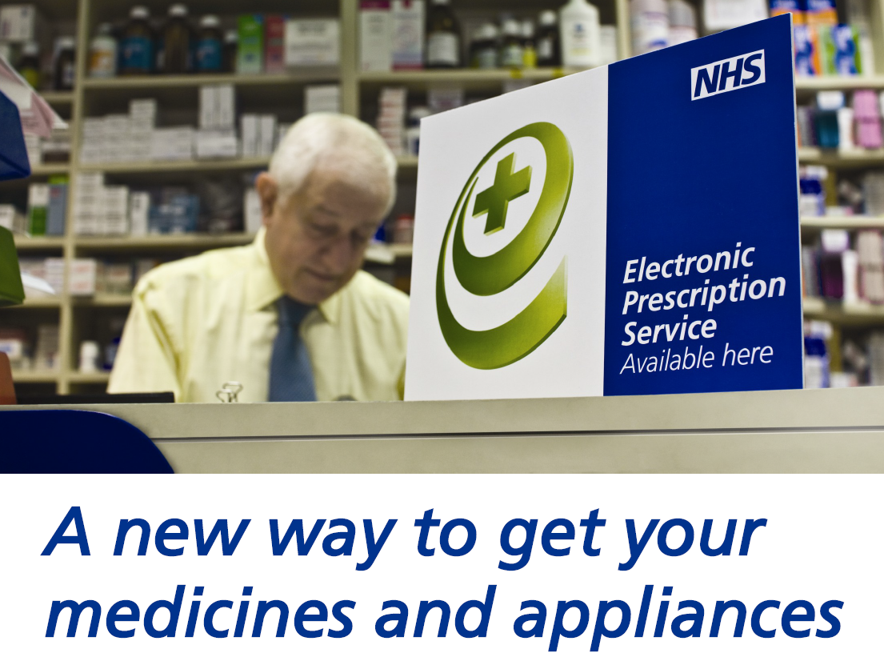
From September the GPs working here will be able to produce and transmit a prescription to a pharmacy you have nominated with no need to produce a paper prescription. However you will still be able to have a paper prescription if you want one.
The Electronic Prescription Service (or EPS) will allow you to collect your medications from a pharmacy at a location convenient to you; it could be near your place of work, for example.
If you wish to join in this scheme please go to your preferred pharmacy and let them know you want them to be your nominated pharmacy. They will then register your details and we will know that you have joined the EPS scheme.
If you have already nominated a pharmacy please remember that from September your prescriptions will automatically be sent to this pharmacy unless you ask us to do otherwise. If you are unsure whether you have a nominated pharmacy please check with your pharmacy.

